

Compsoft Technologies

Bangalore,Karnataka

AN INTERNSHIP REPORT ON

“ LEAF NOW ”

## BACHELOR OF ENGINEERING

In

#### INFORMATION SCIENCE AND ENGINEERING

##### Submitted by: VARSHINI C E (1JB19IS118)

##### POORNIMA H S (1JB20IS406)

##### VIDYASHREE S (1JB19IS120)

SJB INSTITUTE OF TECHNOLOGY

(Affiliated to Visvesvaraya Technological University and Approved by AICTE, New Delhi)Accredited By NAAC with ‘A’ Grade

ISO 9001-2015 and 14001-2015 certified Institute

**BengAluru, KArnAtAkA560057**

##### 2020-2021

**ABOUT THE COMPANY**

CST is a digital service provider that aims to provide software, designing and marketing solutions to individuals and businesses. At CST , we believe that service and quality is the key to success

We provide all kinds of technological and designing solutions from Billing Software to Web Designs or any custom demand that you may have. Experience the service like none other!

Some of our services include:

* Development - We develop responsive, functional and super-fastwebsites.
* We keep User Experience in mind while creating websites. A website should load quickly and shouldbeaccessible even on a small view-port and slow internetconnection.
* Mobile Application - We offer a wide range of professional Android, iOS&Hybrid app development services for our global clients, from a start up to a largeenterprise.
* Design - We offer professional Graphic design, Brochure design & Logo design. We are expertsin crafting visual content to convey the right message to thecustomers.
* Consultancy - We are here to provide you with expert advice on your design anddevelopment requirement.
* Videos - We create a polished professional video that impresses youraudience.

# Table of Contents

#### Contents PageNo.

**Table of Contents I**

Overview of the project 4

About 5

Tools used 6

Implementation 7-20

Snapshots 21-22

Bibliography 23

##### (I)

### OVERVIEW OF THE PROJECT

**Project Name**: LEAF NOW

**Team Members:** VARSHINI C E

POORNIMA H S

VIDYASHREE S

**OVERVIEW AND DETAILS OF PROJECT.**

Ever since industrialisation started the care for plants has made it to our least priority list, Even though mankind requires plants to balance the food chain that he’s a part of, but the plant enthusiasts are everywhere, be it big metropolitan cities or rural areas, so we aim to bring in a platform that can connect these plant/nature enthusiasts and help them exchange/sell them plants or donate seeds/plants as part of the green initiative.

The most crucial feature of LEAF NOW is connecting enthusiasts, which means that users are able to create an account on the site and can start filling out a form to submit their services.

The second feature is encouraging users to sell/buy/donate plants/seeds, by letting them know the importance of the same.

The third important feature is the discussion page, which sets up a discussion page for the enthusiasts to start a discussion on topics that they like.

At last the user is able to get his/her transactions of donating/buying/selling plants over a period of time in pdf format.

**ABOUT** **LEAF NOW**

**Detailed understanding of the concept of the Project .**

We spend money on a whole lot of things. We buy endless money shopping for our favorite things in the market. It’s time we think a little about our fellow beings on this earth, especially trees since most of them are usually cut down and brought down to earth and we rarely take an effort to re plant them again.

If we cannot spare time for re-planting a tree, there are other means through which we can volunteer ourselves in the act of growing more trees.

Let us first see why we need trees around us. Don’t we all need fresh air in our surroundings? We need air to breathe, to carry out the process of respiration and generate energy for the body.

Plants carry out photosynthesis and generate food. Oxygen is thus a very essential part of our daily activities and these huge lump sum hordes of oxygen are not got by plucking from the atmosphere.

### TOOLS USED

**Software Requirements**

* + Visual Studio Code.
  + Google Chrome of latest version.
  + Front End: HTML, CSS, JS
  + Backend : Php, MySQL,Xampp,Python
  + Linux 7.1 or Windows XP/7/8/10 OS or MacOS

**Hardware Requirements**

* + Pentium 200-MHz computer with a minimum of 64 MB of RAM (128 MB of RAM recommended).
  + Monitor with a refresh rate of at least 40Hz for a smoothGUI experience.

# IMPLEMENTATION

The frontend development:

<!doctype html>

<html lang="en">

<head>

<meta charset="utf-8">

<meta name="viewport" content="width=device-width, initial-scale=1">

<meta name="description" content="">

<meta name="author" content="Mark Otto, Jacob Thornton, and Bootstrap contributors">

<meta name="generator" content="Hugo 0.98.0">

<title>Signin Template · Bootstrap v5.2</title>

<link rel="canonical" href="https://getbootstrap.com/docs/5.2/examples/sign-in/">

<link rel="stylesheet" href="C:\Users\Hi\OneDrive\Documents\styles.css">

<link href="/docs/5.2/dist/css/bootstrap.min.css" rel="stylesheet" integrity="sha384-0evHe/X+R7YkIZDRvuzKMRqM+OrBnVFBL6DOitfPri4tjfHxaWutUpFmBp4vmVor" crossorigin="anonymous">

<!-- CSS only -->

<link href="https://cdn.jsdelivr.net/npm/bootstrap@5.2.0-beta1/dist/css/bootstrap.min.css" rel="stylesheet" integrity="sha384-0evHe/X+R7YkIZDRvuzKMRqM+OrBnVFBL6DOitfPri4tjfHxaWutUpFmBp4vmVor" crossorigin="anonymous">

<!-- Favicons -->

<link rel="apple-touch-icon" href="/docs/5.2/assets/img/favicons/apple-touch-icon.png" sizes="180x180">

<link rel="icon" href="/docs/5.2/assets/img/favicons/favicon-32x32.png" sizes="32x32" type="image/png">

<link rel="icon" href="/docs/5.2/assets/img/favicons/favicon-16x16.png" sizes="16x16" type="image/png">

<link rel="manifest" href="/docs/5.2/assets/img/favicons/manifest.json">

<link rel="mask-icon" href="/docs/5.2/assets/img/favicons/safari-pinned-tab.svg" color="#712cf9">

<link rel="icon" href="/docs/5.2/assets/img/favicons/favicon.ico">

<meta name="theme-color" content="#712cf9">

<style>

.bd-placeholder-img {

font-size: 1.125rem;

text-anchor: middle;

-webkit-user-select: none;

-moz-user-select: none;

user-select: none;

}

@media (min-width: 768px) {

.bd-placeholder-img-lg {

font-size: 3.5rem;

}

}

.b-example-divider {

height: 3rem;

background-color: rgba(0, 0, 0, .1);

border: solid rgba(0, 0, 0, .15);

border-width: 1px 0;

box-shadow: inset 0 .5em 1.5em rgba(0, 0, 0, .1), inset 0 .125em .5em rgba(0, 0, 0, .15);

}

.b-example-vr {

flex-shrink: 0;

width: 1.5rem;

height: 100vh;

}

.bi {

vertical-align: -.125em;

fill: currentColor;

}

.nav-scroller {

position: relative;

z-index: 2;

height: 2.75rem;

overflow-y: hidden;

}

.nav-scroller .nav {

display: flex;

flex-wrap: nowrap;

padding-bottom: 1rem;

margin-top: -1px;

overflow-x: auto;

text-align: center;

white-space: nowrap;

-webkit-overflow-scrolling: touch;

}

</style>

<!-- Custom styles for this template -->

<link href="signin.css" rel="stylesheet">

</head>

<body class="text-center">

<main class="form-signin w-100 m-auto">

<form>

<img class="mb-4" src="https://thumbs.dreamstime.com/b/small-plant-growing-garden-sunlight-137371294.jpg" alt="" width="72" height="57">

<h1 style="color:purple" class="h3 mb-3 fw-normal">Welcome to LeafNow</h1>

<h2 class="h3 mb-3 fw-normal">Please sign in</h2>

<div class="form-floating">

<input type="email" class="form-control" id="floatingInput" placeholder="name@example.com">

<label for="floatingInput">Email address</label>

</div>

<div class="form-floating">

<input type="password" class="form-control" id="floatingPassword" placeholder="Password">

<label for="floatingPassword">Password</label>

</div>

<div class="checkbox mb-3">

<label style="color:#FFF">

<input type="checkbox" value="remember-me"> Remember me

</label>

</div>

<button class="w-100 btn btn-lg btn-primary" type="submit">Sign in</button>

</form>

</main>

</body>

</html>

CSS Styles:

nav.nav-center ul {

    text-align: center;

    padding-top: 20px;

    padding-left: 100px;

}

nav.nav-center ul li {

    display: inline;

    float: none;

}

nav.nav-center ul li a {

    display: inline-block;

}

Add plant form:

<!doctype html>

<html lang="en">

<head>

<meta charset="utf-8">

<meta name="viewport" content="width=device-width, initial-scale=1">

<meta name="description" content="">

<meta name="author" content="Mark Otto, Jacob Thornton, and Bootstrap contributors">

<meta name="generator" content="Hugo 0.98.0">

<title>Signin Template · Bootstrap v5.2</title>

<link rel="canonical" href="https://getbootstrap.com/docs/5.2/examples/sign-in/">

<link rel="stylesheet" href="">

<h1 style="text-align:center">Welcome to LeafNow </h1>

<link href="/docs/5.2/dist/css/bootstrap.min.css" rel="stylesheet" integrity="sha384-0evHe/X+R7YkIZDRvuzKMRqM+OrBnVFBL6DOitfPri4tjfHxaWutUpFmBp4vmVor" crossorigin="anonymous">

<!-- CSS only -->

<link href="https://cdn.jsdelivr.net/npm/bootstrap@5.2.0-beta1/dist/css/bootstrap.min.css" rel="stylesheet" integrity="sha384-0evHe/X+R7YkIZDRvuzKMRqM+OrBnVFBL6DOitfPri4tjfHxaWutUpFmBp4vmVor" crossorigin="anonymous">

<!-- Favicons -->

<link rel="apple-touch-icon" href="/docs/5.2/assets/img/favicons/apple-touch-icon.png" sizes="180x180">

<link rel="icon" href="/docs/5.2/assets/img/favicons/favicon-32x32.png" sizes="32x32" type="image/png">

<link rel="icon" href="/docs/5.2/assets/img/favicons/favicon-16x16.png" sizes="16x16" type="image/png">

<link rel="manifest" href="/docs/5.2/assets/img/favicons/manifest.json">

<link rel="mask-icon" href="/docs/5.2/assets/img/favicons/safari-pinned-tab.svg" color="#712cf9">

<link rel="icon" href="/docs/5.2/assets/img/favicons/favicon.ico">

<meta name="theme-color" content="#712cf9">

<style>

.bd-placeholder-img {

font-size: 1.125rem;

text-anchor: middle;

-webkit-user-select: none;

-moz-user-select: none;

user-select: none;

}

@media (min-width: 768px) {

.bd-placeholder-img-lg {

font-size: 3.5rem;

}

}

.b-example-divider {

height: 3rem;

background-color: rgba(0, 0, 0, .1);

border: solid rgba(0, 0, 0, .15);

border-width: 1px 0;

box-shadow: inset 0 .5em 1.5em rgba(0, 0, 0, .1), inset 0 .125em .5em rgba(0, 0, 0, .15);

}

.b-example-vr {

flex-shrink: 0;

width: 1.5rem;

height: 100vh;

}

.bi {

vertical-align: -.125em;

fill: currentColor;

}

.nav-scroller {

position: relative;

z-index: 2;

height: 2.75rem;

overflow-y: hidden;

}

.nav-scroller .nav {

display: flex;

flex-wrap: nowrap;

padding-bottom: 1rem;

margin-top: -1px;

overflow-x: auto;

text-align: center;

white-space: nowrap;

-webkit-overflow-scrolling: touch;

}

</style>

<!-- Custom styles for this template -->

<link href="signin.css" rel="stylesheet">

</head>

<body class="text-center">

<main class="form-signin w-100 m-auto">

<form>

<img class="mb-4" src="/docs/5.2/assets/brand/bootstrap-logo.svg" alt="" width="72" height="57">

<h1 class="h3 mb-3 fw-normal">Please sign in</h1>

<div class="form-floating">

<input type="email" class="form-control" id="floatingInput" placeholder="name@example.com">

<label for="floatingInput">Email address</label>

</div>

<div class="form-floating">

<input type="password" class="form-control" id="floatingPassword" placeholder="Password">

<label for="floatingPassword">Password</label>

</div>

<div class="checkbox mb-3">

<label>

<input type="checkbox" value="remember-me"> Remember me

</label>

</div>

<button class="w-100 btn btn-lg btn-primary" type="submit">Sign in</button>

<p class="mt-5 mb-3 text-muted">&copy; 2017–2022</p>

</form>

</main>

</body>

</html>

Customer page:

{% extends 'user/base.html' %}

{% block content %}

<div class="container row">

<h2>Orders Placed</h2>

{% for plant in order_items %}

<div class=" col s12 m12 l4" style="margin-top: 50px;">

<div class="center card">

<div class="card-image">

<img src="{{ plant.product.image.url }}" style="height: 300px;">

<span class="card-title white-text">{{ plant.product.name|title }}</span>

</div>

<div class="card-content">

<left>

<p>{{ plant.product.description }}</p>

<p>By {{ plant.product.manager.nursery }}</p>

<p>Rs. {{ plant.product.price }}</p>

<p>Quantity: {{ plant.quantity }}</p>

</left>

</div>

</div>

</div>

{% endfor %}

</div>

{% endblock %}

Cart page:

{% extends 'user/base.html' %}

{% block content %}

{% if order.get_cart_items is not 0 %}

<div id='cart-card' class="container col s12 m12 l12">

<div class="card horizontal">

<div class="card-stacked">

<div class="card-content">

<div class="row">

<div class="col l4 m4 s12">

Items: {{ order.get_cart_items }}

</div>

<div class="col l4 m4 s12">

Total: Rs. {{ order.get_cart_total|floatformat:2}}

</div>

<div class="col l4 m4 s12">

<a href="{% url 'nurseryapp:checkout' %}" class="waves-effect waves-light btn right">Checkout</a>

</div>

</div>

</div>

</div>

</div>

</div>

{% else %}

<h2 class="center">Oops! there's nothing in the cart</h2>

{% endif %}

{% for item in items %}

<div id='cart-card' class="container col s12 m12 l12">

<div class="card horizontal">

<div class="card-stacked">

<div class="card-content">

<div class="row">

<div class="col l3 m3 s3">

<img src="{{ item.product.image.url }}" alt="" height="100px" width="100px">

</div>

<div class="col l3 m3 s3">

{{ item.product.name|title }}<br>

{{ item.product.description }}<br>

Rs. {{ item.product.price }}

</div>

<div class="col l3 m3 s3">

Quantity:<br>

<a class="btn btn-small btn-flat" href="{% url 'nurseryapp:cart_action' item.product.id 0 %}"><i class="material-icons">remove</i></a>

{{ item.quantity }}

<a class="btn btn-small btn-flat" href="{% url 'nurseryapp:cart_action' item.product.id 1 %}"><i class="material-icons">add</i></a>

</div>

<div class="col l3 m3 s3">

Price:<br>Rs. {{ item.get_total }}

</div>

</div>

</div>

</div>

</div>

</div>

{% endfor %}

{% endblock %}

Importance page:

<!doctype html>

<html lang="en">

<head>

<link rel="stylesheet" href="C:\Users\Hi\OneDrive\Documents\styles.css">

</head>

<body>

<h3 style="color:white">We spend money on a whole lot of things. We buy endless money shopping for our favorite things in the market. It’s time we think a little about our fellow beings on this earth, especially trees since most of them are usually cut down and brought down to earth and we rarely take an effort to re plant them again.

If we cannot spare time for re-planting a tree, there are other means through which we can volunteer ourselves in the act of growing more trees.

Let us first see why we need trees around us. Don’t we all need fresh air in our surroundings? We need air to breathe, to carry out the process of respiration and generate energy for the body.

Plants carry out photosynthesis and generate food. Oxygen is thus a very essential part of our daily activities and these huge lump sum hordes of oxygen are not got by plucking from the atmosphere.

</h3>

<br>

<br>

</body>

</html>

Checkout page:

{% extends 'user/base.html' %}

{% block content %}

{% if items %}

<div id='cart-card' class="container col s12 m12 l12">

<div class="card horizontal">

<div class="card-stacked">

<div class="card-content">

<div>

<a class="btn " style="display: inline-block; margin-top: 10px;" href="{% url 'nurseryapp:cart' %}">Back To Cart</a><br><br>

</div>

<div class="row">

<div class="col l8 m12 s12">

<div class="row">

<form class="col s12" id="form" method="POST" action="{% url 'nurseryapp:process_order' %}">

{% csrf_token %}

<div id="shipping-info">

<h5 class="left-align" style="display: inline-block;">Enter Address</h5>

<div class="row">

<div class="input-field col s6">

<input id="address" type="text" class="validate" name="address" required>

<label for="address">Address</label>

</div>

<div class="input-field col s6">

<input id="city" type="text" class="validate" name="city" required>

<label for="city">City</label>

</div>

</div>

<div class="row">

<div class="input-field col s6">

<input id="state" type="text" class="validate" name="state" required>

<label for="state">State</label>

</div>

<div class="input-field col s6">

<input id="pincode" type="number" class="validate" name="pincode" required>

<label for="pincode">PinCode</label>

</div>

</div>

</div>

<input class="btn" type="submit" value="Proceed for payment">

</form>

</div>

</div>

<div class="col l4 m12 s12" id="order-summary">

<h5>Order Summary</h5><hr><br>

{% for item in items %}

<div class="row">

<div class="col l3 m3 s3">

<img src="{{ item.product.image.url }}" alt="" height="50px" width="50px">

</div>

<div class="col l3 m3 s3">

"{{ item.product.name|title }}"

</div>

<div class="col l3 m3 s3">

{{ item.quantity }} Pot

</div>

<div class="col l3 m3 s3">

Rs. {{ item.get_total }}

</div>

</div>

{% endfor %}

<hr>

<p>Total Plants: {{ order.get_cart_items }}</p><br>

<p>Total Price: Rs. {{ order.get_cart_total }}</p>

<hr>

</div>

</div>

</div>

</div>

</div>

</div>

{% else %}

<h2>Oops! there's nothing in the cart</h2>

{% endif %}

{% endblock %}

Login page:

{% extends 'user/base.html' %}

<!-- {% block title %}Login{% endblock %} -->

{% block content %}

{% if not user.is_authenticated %}

<div class="container">

<h2>Login</h2>

<form class="card" method="POST" action="{% url 'nurseryapp:login' %}" style="padding: 25px;">

{% csrf_token %}

Email:

<input type="email" name="username"><br>

Password:

<input type="password" name=password value=""><br>

<button class="btn" type="submit">Login</button>

</form>

</div>

{% else %}

<h2>You're already loggedIn</h2>

{% endif %}

{% endblock %}

Python file(manage):

#!/usr/bin/env python

"""Django's command-line utility for administrative tasks."""

import os

import sys

def main():

"""Run administrative tasks."""

os.environ.setdefault('DJANGO_SETTINGS_MODULE', 'nursery.settings')

try:

from django.core.management import execute_from_command_line

except ImportError as exc:

raise ImportError(

"Couldn't import Django. Are you sure it's installed and "

"available on your PYTHONPATH environment variable? Did you "

"forget to activate a virtual environment?"

) from exc

execute_from_command_line(sys.argv)

if __name__ == '__main__':

main()

### SNAPSHOTS

**1.**

**The front end of the project**

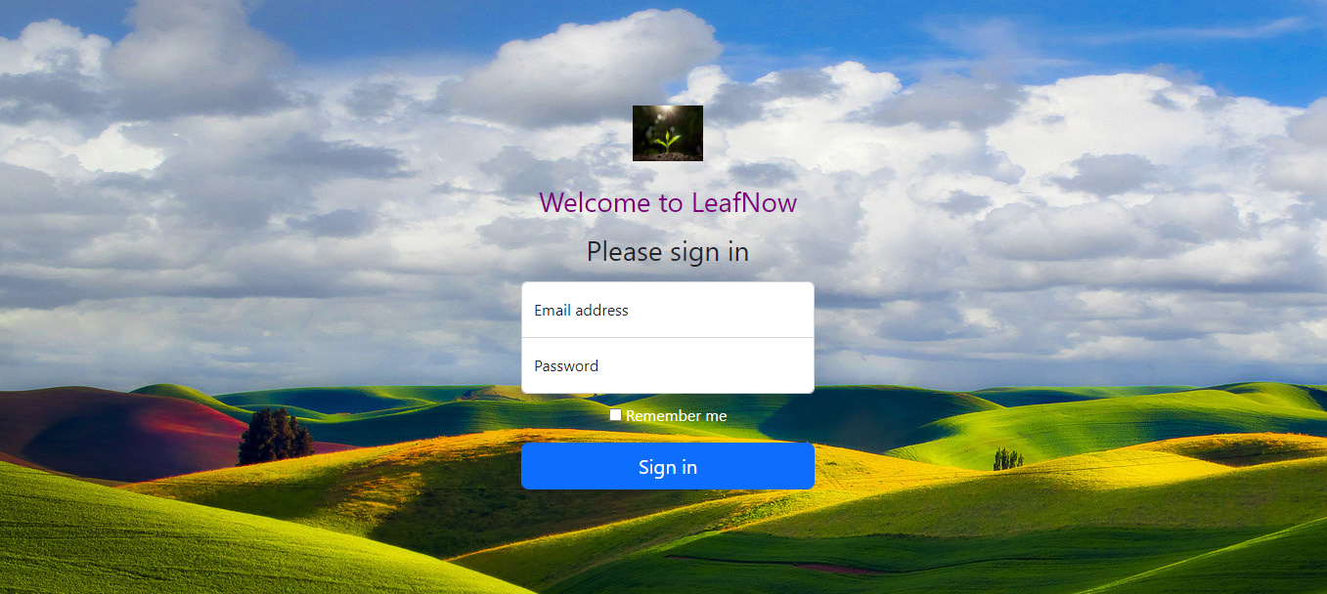

**2.**

**The page that conveys the importance of plant donation and asks for the user to donate or buy plants.**

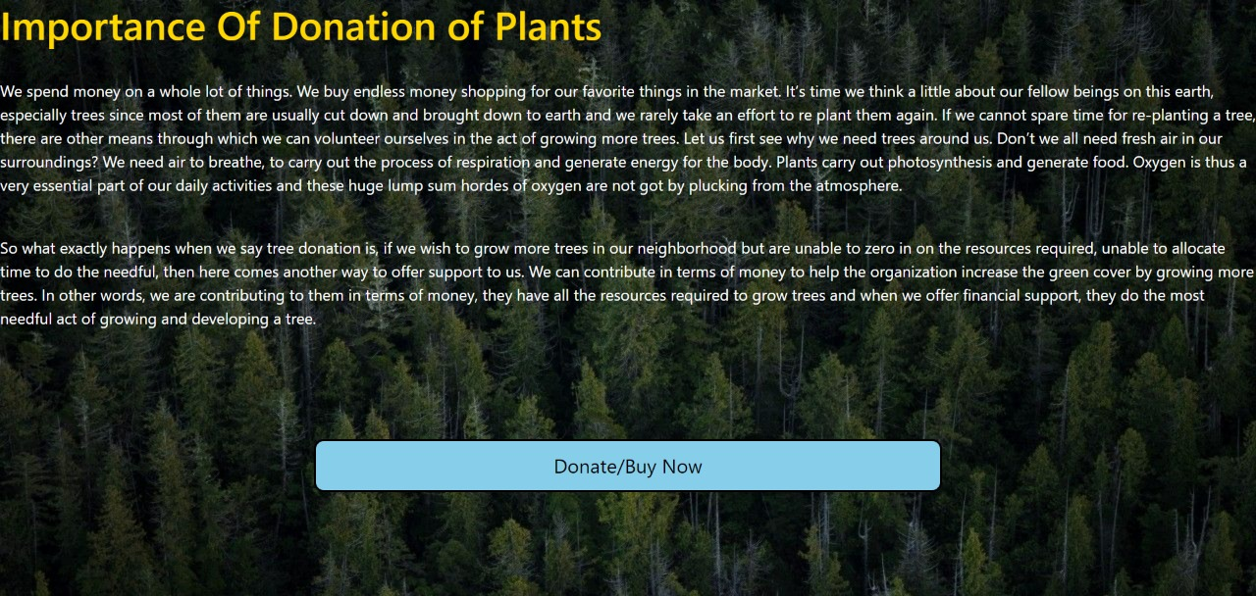

### BIBLIOGRAPHY

* https://[www.w3schools.com](http://www.w3schools.com/)
* https://www.geeksforgeeksorg
* https://freefrontend.com
* <https://css-tricks.com/>
* https://www.takeiteasyengineers.com